Integrated Church Management
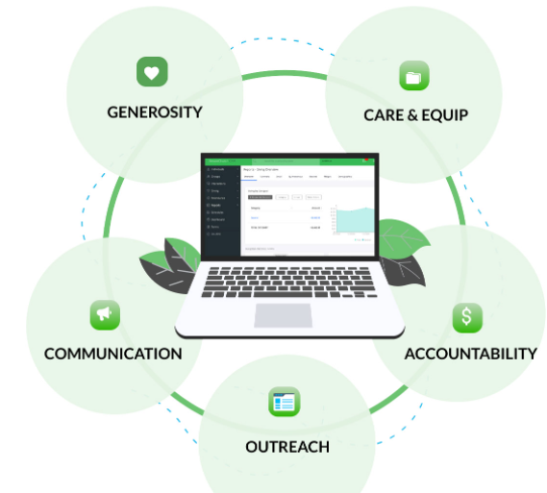
links
https://www.simplechurchcrm.com/what-is-church-management-software/

https://www.shelbysystems.com/blog/why-your-church-needs-integrated-church-management-software/

Research Synopsis

Church Manage Professional is the best selling, powerful church administration software which allows you to handle details of over 50,000 members,

church finances, church events calenders, easy member search and grouping,

Mange member contributions, manage/write/print letters, includes general ledger, import and export member data from multiple file formats, backup your database to cd or flashdrive. Includes free fast email technical support Not online based, no need for online access No monthly fees like similar software, one payment for lifetime access

Manage, Track and print member details including Personal information, member status, age group, address/email phone number, photo, member personal notes, data/notes on member gifts,

Manage, Track and print members contribution details

Manage, Track and print member attendance

Manage, Track and print various Custom letters for members

Manage, Track and print calender with events and which members are attending

Manage, Track and print multiple Church Bank Accounts and transactions Operating Systems: Windows

Manage, Track and print member details including Personal information
- Member status, age group, address/email phone number, photo, member personal notes, data/notes on member gifts

- Manage, Track and print calendar with events and which members are attending

- Manage, Track and print various Custom letters for members

